In order to drive the DC motors that came with the Magician chassis kit, I put together the circuit below using the included 754410 H-bridge chip.

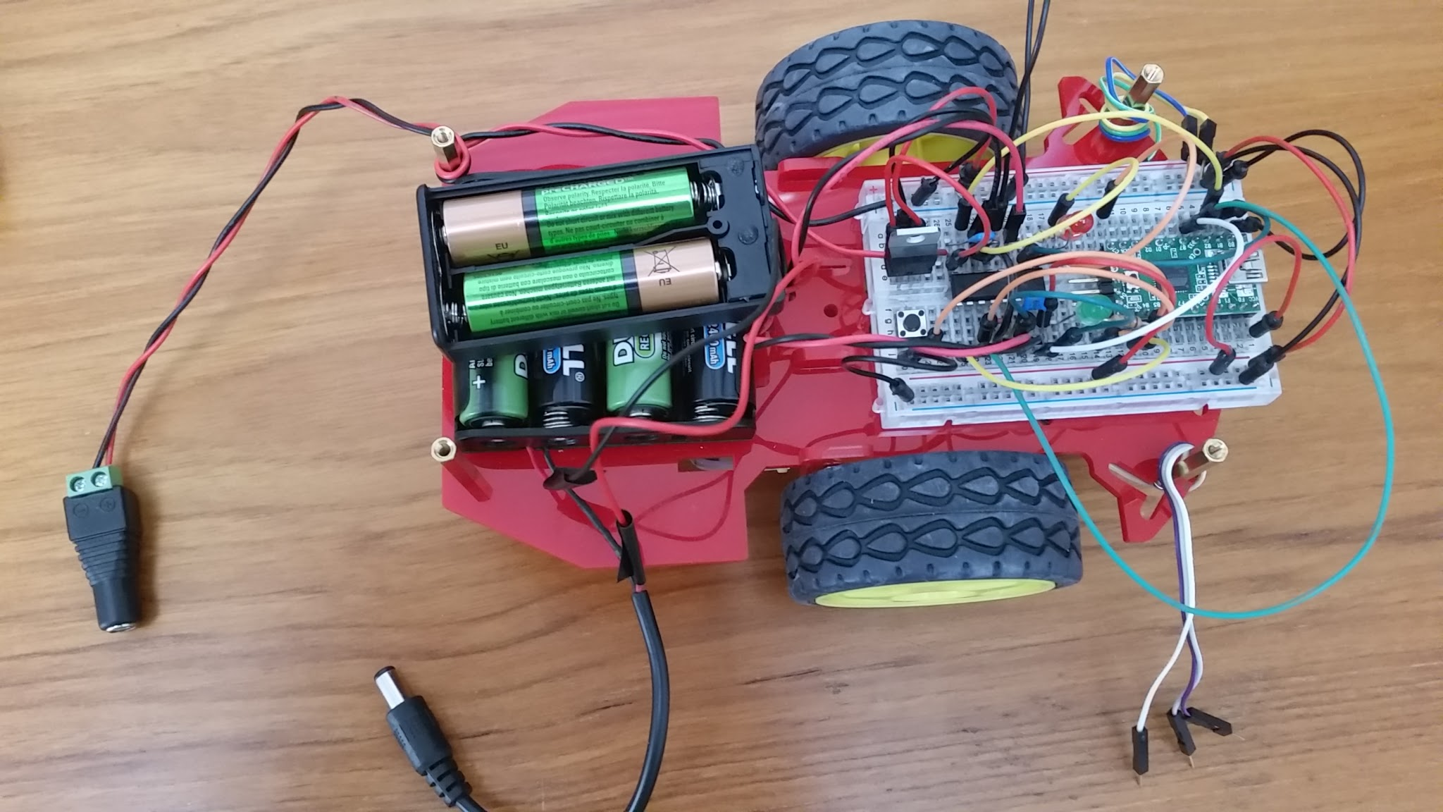

The half-size breadboard holds the Teensy microcontroller board, the 754410, a push button switch, and a few additional components. Here’s the circuit schematic:
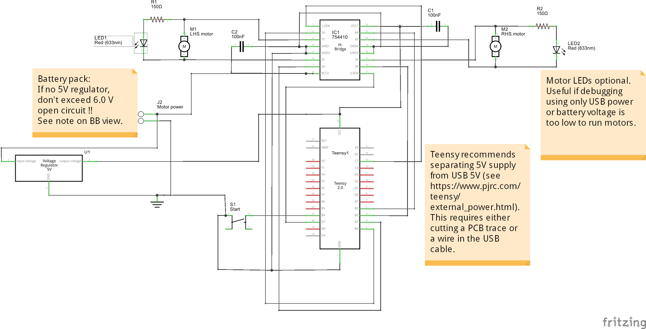

And here’s the Fritzing view of the breadboard wiring:

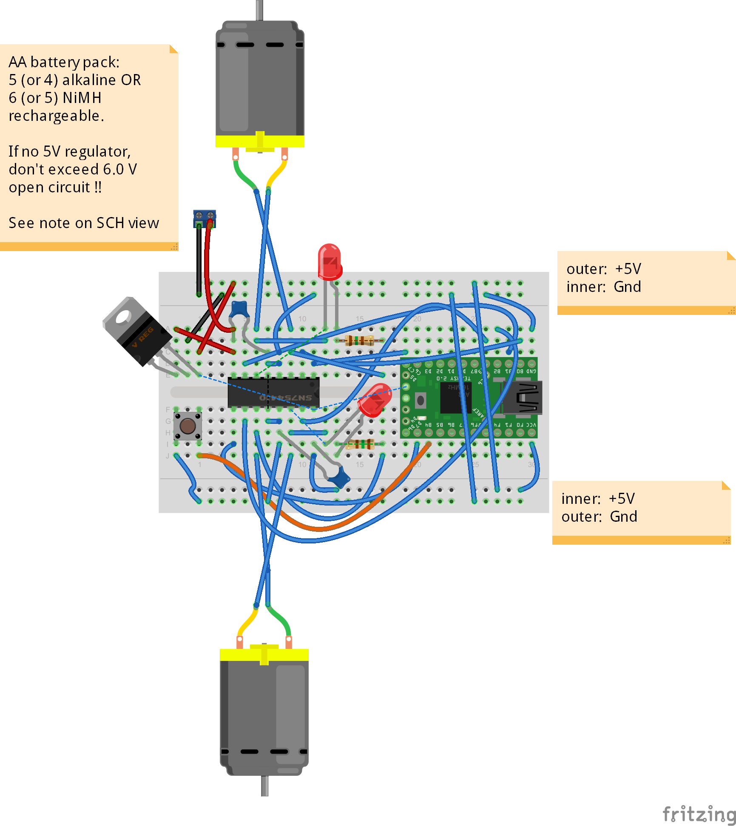

Power Supply
I was a little concerned about the battery power supply. At the start I wired up just one motor and jumpered the H-bridge inputs to run it using 4 AA rechargeable (NiMH) batteries to supply about 5.2 V (no load). The motor ran, but the power seemed just enough to overcome the friction in the gearbox. I wanted to increase the motor voltage, but I also knew that supplying too high a voltage to the digital logic would be bad. In particular the Teensy 2.0 schematic doesn’t include any kind of voltage regulator, so voltages above the rating of the ATmega32U4 chip would be risky.

Looking at datasheets I found the following ratings:
- ATmega32U4 chip has an Absolute Maximum operating voltage of 6.0V and most datasheet values are obtained at Vcc <= 5.5 V.
- The 754410 has an Absolute Maximum of 36V for Vcc1 (the logic supply voltage) but the datasheet recommends 5.5V max.
- The motors that came with the kit appear to be rated at 6.0 V max with a recommended voltage of 4.5V.

I wanted to use rechargeable batteries, but when I measured the voltages in the table below, I found that 4 AA NiMH batteries would supply < 3 V to the motor and only 4.7 V to the logic. Alkaline batteries provided > 6.0 V so I didn’t want to risk the Teensy by using this for logic power.

Without a voltage regulator
Battery config | No load battery voltage (V) | Battery voltage (V) - one motor running | Motor voltage (V) - one motor running | Motor Speed
4x NiMH AA | 5.1 | 4.7 | 2.95 | Slow; expected to be worse with two motors running
4x Alkaline AA | 6.27 |  |  | Didn’t try

Next I added an additional AA battery holder in series with the original 4-cell holder so I could use 5 or 6 cells in series. I also added a 7805 voltage regulator to the breadboard to provide 5 V for logic power, while I used the full battery voltage for the Vcc2 input to the 754410 H-bridge chip. Measuring voltages with this configuration gave the table below.

With a voltage regulator for logic 5 V power
Battery config | No load battery voltage (V) | Logic voltage (V) - motor off | Logic voltage (V) - one motor running | Motor voltage (V) - one motor running | Motor speed
4x Alkaline AA | 6.27 | 4.63 | 4.09 | 3.78 | Medium
5x Alkaline AA | 7.77 | 4.97 | 4.96 | 5.12 | Fast
5x NiMH AA | 6.39 | 4.84 | 4.44 | 4.11 | Medium
6x NiMH AA | 7.68 | 4.96 | 4.96 | 5.25 | Fast

I concluded it was best to use the regulator with either 6 rechargeable AA or 5 alkaline AA batteries. Things would probably be functional with 5 NiMH or 4 alkaline cells but the motor would run slower and the logic voltage would be on the low side. I made the measurements above with only one motor running - the voltages will likely be a bit lower when both motors run simultaneously.

Teensy Conflict Between USB Power and Battery Power

The Teensy site recommends separating the USB power from an external power source used to power Teensy Vcc. Three possible modifications are suggested on that site. Some possible scenarios to avoid the conflict between USB power and external power:
- Make no mods, but remember (every time!) to disconnect the USB cable before connecting the battery. And vice versa. Personally I doubt that I would remember this every time.
- Make one of the first two mods recommended by Teensy (either cut the PCB trace or cut the USB wire). This always avoids the conflict, but means that the battery must always be connected to power the Teensy (even when uploading code).
- Make the third mod suggested by Teensy which powers the Teensy from the USB power if no battery is connected. The disadvantage is that you have to solder one diode to the Teensy PCB and add another diode in series with the battery connection. Also, the drop across the diode will reduce the available voltage.

